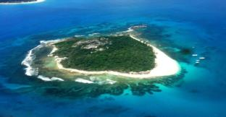
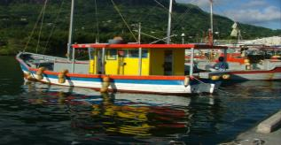
SEYCHELLES MARINE SPATIAL PLANNING (msp) INITIATIVE
MSP Steering Committee
Meeting 3
Wednesday 14th January 2015
1:30 PM-4:00 PM
SFA Training Room

Agenda

Meeting Objectives:
- To review and discuss a preliminary zoning design options for Seychelles EEZ (Zones A, C, D, E)
- To review the UNDP PA Validation work in the context of Seychelles EEZ zoning (Zone B)
- To provide direction to the MSP Technical Team on questions related to the zoning design

# | Time | Topic
1 | 1:30 – 1:45 PM | Opening  - Welcome and introductions  - Agenda review
2 | 1:45 – 2:00 PM | Update on MSP Process  - Adoption of Minutes from Steering Committee #2  - Timelines and workplan
3 | 2:00 – 3:00 PM | Preliminary zoning design options for Zones A, C, D and E  - Presentation of draft zones  - Discussion, including how to make decisions for prioritising objectives (zone type) for a location and the recommended or compatible uses within a zone.
4 | 3:30 – 3:30 PM | Using the UNDP PA work to inform the design options for Zone B  - Guidance from Steering Committee
6 | 3:30 – 3:45 PM | Other Business
7 | 3:45 – 4:00 PM | Wrap-up and Schedule for Next Meeting
 | 4:00 PM | Adjourn

