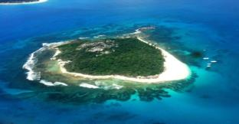
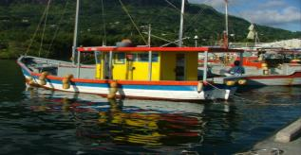
SEYCHELLES MARINE SPATIAL PLANNING (msp) INITIATIVE
MSP Steering Committee
Meeting 1
Tuesday 5 August 2014
8:30 AM - 12:00 PM
Care House, Victoria

Agenda

Meeting Objectives:
- To ensure understanding of the Seychelles Marine Spatial Planning (MSP) process
- To discuss the roles and responsibilities of the MSP Steering Committee
- To introduce, discuss and elicit support for a Seychelles Draft Zoning Proposal

# | Time | Topic
1 | 8:30 - 8:45 | Opening  - Welcome and introductions  - Agenda review
2 | 8:45 - 9:15 | Seychelles Marine Spatial Planning (MSP) Initiative  - Overview and update  - Discussion and questions
3 | 9:15 - 10:00 | MSP Steering Committee Process (Terms of Reference)  - Review  - Discussion and questions
4 | 10:00 - 10:15 | Tea break
5 | 10:15 - 11:30 | Seychelles Draft Zoning Proposal  - Presentation  - Discussion and questions
6 | 11:30 - 11:45 | Matters Arising
7 | 11:45 - 12:00 | Wrap-up

