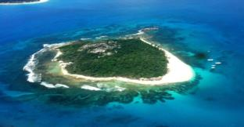
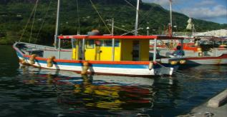
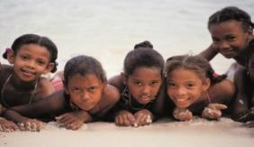
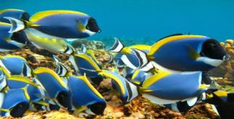
SEYCHELLES MARINE SPATIAL PLANNING (msp) INITIATIVE
MSP Technical Working Group – Marine and Terrestrial
Meeting #2
22 October 2014
8:30 AM - 2:30 PM
Location: SFA Training Room

Agenda
Meeting Objectives:
- To provide an update on the Seychelles Marine Spatial Planning (MSP) Initiative.
- To review and elicit support for methodology to develop draft Zoning Design for Seychelles EEZ.
- To provide spatial information about high priority areas and compatibilities or conflicts within the EEZ.

# | Time | Topic
 | 8:30 - 9:00 | Registration and networking
1 | 9:00 - 9:10 | Opening  - Welcome and Agenda review
2 | 9:10 - 9:40 | Seychelles Marine Spatial Planning (MSP) Initiative  - Process update  - Technical Update: Zoning document, Master List, Compatibility Matrix  - Technical Working Group - Roundtable of Updates
3 | 9:40 - 10:00 | Defining Zones Spatially  - Presentation: Methodology to develop draft Zoning Design  - Discussion and Questions
 | 10:00 - 10:15 | Tea break
4 | 10:15 - 12:15 | Spatial Information for draft Zoning Design  - Quick review of GeoPDF tool and creating spatial information  - Breakout groups: Participatory mapping and identifying compatibilities or conflicts
 | 12:15 – 1:00pm | Lunch
5 | 1:00 – 2:15 | Spatial Information for Zoning Design, continued  - Breakout groups: Participatory mapping and identifying compatibilities or conflicts  - Reporting back to group and Questions
6 | 2:15 – 2:30 | Wrap-up, Next steps, and Adjourn

